Messaging Hub Design
![Messaging]
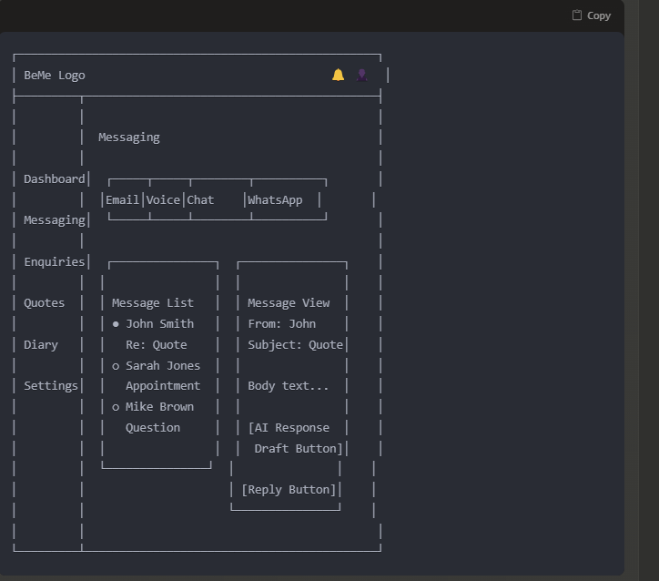

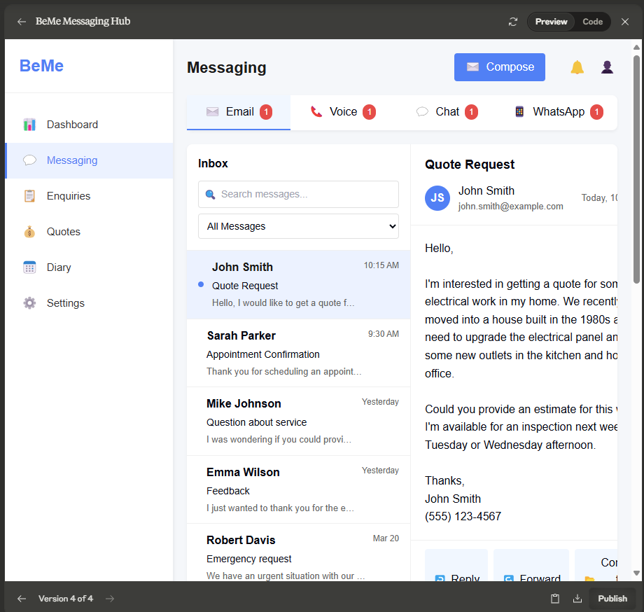
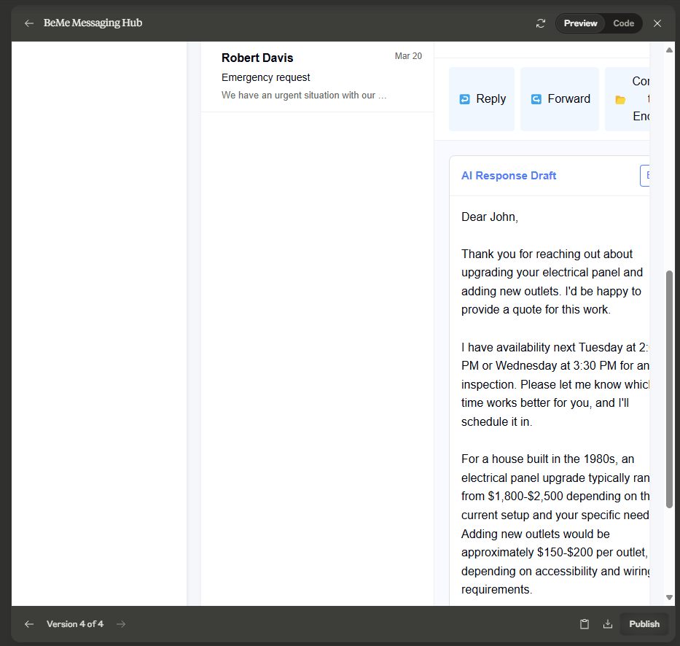

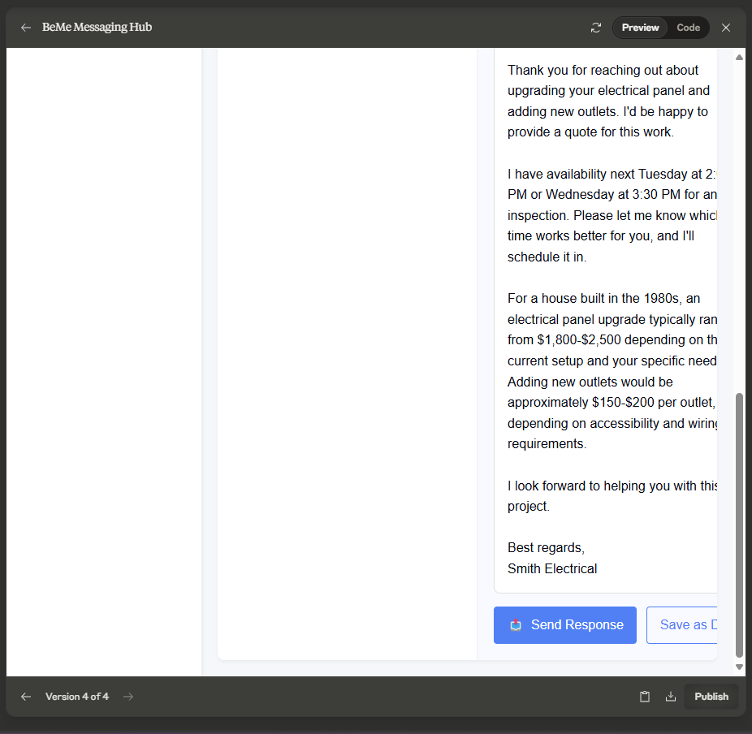

import React, { useState } from 'react';

const Messaging = () => {
const [activeTab, setActiveTab] = useState('email');
const [selectedMessage, setSelectedMessage] = useState(1);

// Sample data
const messages = {
email: [
{ id: 1, from: 'John Smith', subject: 'Quote Request', preview: 'Hello, I would like to get a quote for...', time: '10:15 AM', read: false },
{ id: 2, from: 'Sarah Parker', subject: 'Appointment Confirmation', preview: 'Thank you for scheduling an appointment...', time: '9:30 AM', read: true },
{ id: 3, from: 'Mike Johnson', subject: 'Question about service', preview: 'I was wondering if you could provide...', time: 'Yesterday', read: true },
{ id: 4, from: 'Emma Wilson', subject: 'Feedback', preview: 'I just wanted to thank you for the excellent...', time: 'Yesterday', read: true },
{ id: 5, from: 'Robert Davis', subject: 'Emergency request', preview: 'We have an urgent situation with our electrical...', time: 'Mar 20', read: true }
],
voice: [
{ id: 101, from: 'Unknown Number', subject: 'Missed Call', preview: 'Caller left no message', time: '11:05 AM', read: false },
{ id: 102, from: 'Alex Thompson', subject: 'Voicemail (0:45)', preview: 'Hi, I need some help with my circuit breaker...', time: 'Yesterday', read: true },
{ id: 103, from: 'Lisa Brown', subject: 'Voicemail (1:22)', preview: 'Hello, I\'m calling about the quote you sent...', time: 'Mar 20', read: true }
],
chat: [
{ id: 201, from: 'Tom Wilson', subject: 'Website Chat', preview: 'Do you offer emergency services on weekends?', time: '1:30 PM', read: false },
{ id: 202, from: 'Jennifer Lee', subject: 'Website Chat', preview: 'What\'s your service area?', time: 'Yesterday', read: true }
],
whatsapp: [
{ id: 301, from: 'Chris Scott', subject: 'WhatsApp Message', preview: 'Hi there, I need some electrical work done...', time: '2:45 PM', read: false },
{ id: 302, from: 'David Miller', subject: 'WhatsApp Message', preview: 'Thanks for the quick response. Can you...', time: 'Yesterday', read: true }
]
};

// Mock current message content
const currentMessage = {
id: 1,
from: 'John Smith',
email: 'john.smith@example.com',
subject: 'Quote Request',
date: 'Today, 10:15 AM',
content: `Hello,

I'm interested in getting a quote for some electrical work in my home. We recently moved into a house built in the 1980s and need to upgrade the electrical panel and add some new outlets in the kitchen and home office.

Could you provide an estimate for this work? I'm available for an inspection next week on Tuesday or Wednesday afternoon.

Thanks,
John Smith
(555) 123-4567`
};

// AI response draft
const aiResponseDraft = `Dear John,

Thank you for reaching out about upgrading your electrical panel and adding new outlets. I'd be happy to provide a quote for this work.

I have availability next Tuesday at 2:00 PM or Wednesday at 3:30 PM for an inspection. Please let me know which time works better for you, and I'll schedule it in.

For a house built in the 1980s, an electrical panel upgrade typically ranges from $1,800-$2,500 depending on the current setup and your specific needs. Adding new outlets would be approximately $150-$200 per outlet, depending on accessibility and wiring requirements.

I look forward to helping you with this project.

Best regards,
Smith Electrical`;

return (
<div className="app-container">
{/* Sidebar */}
<div className="sidebar">
<div className="logo-container">
<div className="logo">BeMe</div>
</div>
<div className="sidebar-menu">
<div className="menu-item">
<div className="menu-icon">📊</div>
<div className="menu-text">Dashboard</div>
</div>
<div className="menu-item active">
<div className="menu-icon">💬</div>
<div className="menu-text">Messaging</div>
</div>
<div className="menu-item">
<div className="menu-icon">📋</div>
<div className="menu-text">Enquiries</div>
</div>
<div className="menu-item">
<div className="menu-icon">💰</div>
<div className="menu-text">Quotes</div>
</div>
<div className="menu-item">
<div className="menu-icon">📅</div>
<div className="menu-text">Diary</div>
</div>
<div className="menu-item">
<div className="menu-icon">⚙️</div>
<div className="menu-text">Settings</div>
</div>
</div>
</div>

{/* Main Content */}
<div className="main-content">
{/* Header */}
<div className="header">
<div className="page-title">Messaging</div>
<div className="header-actions">
<button className="compose-btn">
<span className="compose-icon">✉️</span>
<span>Compose</span>
</button>
<div className="notification-icon">🔔</div>
<div className="user-profile">👤</div>
</div>
</div>

{/* Messaging Tabs */}
<div className="messaging-tabs">
<div
className={`tab ${activeTab === 'email' ? 'active' : ''}`}
onClick={() => setActiveTab('email')}
>
<span className="tab-icon">✉️</span>
<span className="tab-text">Email</span>
<span className="tab-badge">{messages.email.filter(m => !m.read).length}</span>
</div>
<div
className={`tab ${activeTab === 'voice' ? 'active' : ''}`}
onClick={() => setActiveTab('voice')}
>
<span className="tab-icon">📞</span>
<span className="tab-text">Voice</span>
<span className="tab-badge">{messages.voice.filter(m => !m.read).length}</span>
</div>
<div
className={`tab ${activeTab === 'chat' ? 'active' : ''}`}
onClick={() => setActiveTab('chat')}
>
<span className="tab-icon">💬</span>
<span className="tab-text">Chat</span>
<span className="tab-badge">{messages.chat.filter(m => !m.read).length}</span>
</div>
<div
className={`tab ${activeTab === 'whatsapp' ? 'active' : ''}`}
onClick={() => setActiveTab('whatsapp')}
>
<span className="tab-icon">📱</span>
<span className="tab-text">WhatsApp</span>
<span className="tab-badge">{messages.whatsapp.filter(m => !m.read).length}</span>
</div>
</div>

{/* Messaging Interface */}
<div className="messaging-interface">
{/* Message List */}
<div className="message-list">
<div className="list-header">
<div className="list-title">Inbox</div>
<div className="list-actions">
<div className="search-box">
<input type="text" placeholder="Search messages..." />
<span className="search-icon">🔍</span>
</div>
<select className="filter-dropdown">
<option>All Messages</option>
<option>Unread</option>
<option>Read</option>
</select>
</div>
</div>
<div className="messages">
{messages[activeTab].map(message => (
<div
key={message.id}
className={`message-item ${message.read ? '' : 'unread'} ${selectedMessage === message.id ? 'selected' : ''}`}
onClick={() => setSelectedMessage(message.id)}
>
<div className="message-status">
{!message.read && <div className="unread-dot"></div>}
</div>
<div className="message-content">
<div className="message-sender">{message.from}</div>
<div className="message-subject">{message.subject}</div>
<div className="message-preview">{message.preview}</div>
</div>
<div className="message-time">{message.time}</div>
</div>
))}
</div>
</div>

{/* Message View */}
<div className="message-view">
{selectedMessage && (
<>
<div className="message-header">
<div className="message-subject-line">
<h2>{currentMessage.subject}</h2>
</div>
<div className="message-info">
<div className="sender-info">
<div className="sender-avatar">JS</div>
<div className="sender-details">
<div className="sender-name">{currentMessage.from}</div>
<div className="sender-email">{currentMessage.email}</div>
</div>
</div>
<div className="message-date">{currentMessage.date}</div>
</div>
</div>

<div className="message-body">
<pre>{currentMessage.content}</pre>
</div>

<div className="message-actions">
<div className="action-buttons">
<button className="action-btn">
<span className="action-icon">↩️</span>
<span>Reply</span>
</button>
<button className="action-btn">
<span className="action-icon">↪️</span>
<span>Forward</span>
</button>
<button className="action-btn">
<span className="action-icon">📂</span>
<span>Convert to Enquiry</span>
</button>
</div>
</div>

<div className="message-reply">
<div className="ai-response">
<div className="ai-header">
<h3>AI Response Draft</h3>
<button className="edit-btn">Edit</button>
</div>
<div className="ai-content">
<pre>{aiResponseDraft}</pre>
</div>
</div>

<div className="reply-actions">
<button className="send-btn">
<span className="send-icon">📤</span>
<span>Send Response</span>
</button>
<button className="save-btn">Save as Draft</button>
</div>
</div>
</>
)}
</div>
</div>
</div>

<style jsx>{`
.app-container {
display: flex;
min-height: 100vh;
font-family: 'Inter', sans-serif;
background-color: #f5f7fa;
}

/* Sidebar styles */
.sidebar {
width: 240px;
background-color: white;
box-shadow: 2px 0 4px rgba(0, 0, 0, 0.05);
padding: 20px 0;
display: flex;
flex-direction: column;
}

.logo-container {
padding: 0 20px 20px;
border-bottom: 1px solid #f0f0f0;
margin-bottom: 20px;
}

.logo {
font-size: 24px;
font-weight: bold;
color: #3B82F6;
}

.sidebar-menu {
display: flex;
flex-direction: column;
flex-grow: 1;
}

.menu-item {
display: flex;
align-items: center;
padding: 12px 20px;
cursor: pointer;
transition: background-color 0.2s;
border-left: 3px solid transparent;
}

.menu-item:hover {
background-color: #f5f7fa;
}

.menu-item.active {
background-color: #ebf2ff;
border-left-color: #3B82F6;
}

.menu-icon {
margin-right: 12px;
font-size: 18px;
}

.menu-text {
font-size: 15px;
color: #333;
}

.menu-item.active .menu-text {
font-weight: 500;
color: #3B82F6;
}

/* Main content styles */
.main-content {
flex: 1;
padding: 20px;
overflow-y: auto;
display: flex;
flex-direction: column;
}

.header {
display: flex;
justify-content: space-between;
align-items: center;
margin-bottom: 20px;
}

.page-title {
font-size: 22px;
font-weight: 600;
color: #1a1a1a;
}

.header-actions {
display: flex;
align-items: center;
}

.compose-btn {
display: flex;
align-items: center;
background-color: #3B82F6;
color: white;
border: none;
border-radius: 4px;
padding: 8px 16px;
margin-right: 16px;
cursor: pointer;
font-weight: 500;
transition: background-color 0.2s;
}

.compose-btn:hover {
background-color: #2563eb;
}

.compose-icon {
margin-right: 8px;
}

.notification-icon, .user-profile {
font-size: 20px;
margin-left: 16px;
cursor: pointer;
}

/* Messaging tabs */
.messaging-tabs {
display: flex;
background-color: white;
border-radius: 8px;
margin-bottom: 20px;
box-shadow: 0 2px 4px rgba(0, 0, 0, 0.05);
}

.tab {
display: flex;
align-items: center;
padding: 12px 20px;
cursor: pointer;
border-bottom: 2px solid transparent;
flex: 1;
justify-content: center;
}

.tab:hover {
background-color: #f8faff;
}

.tab.active {
border-bottom-color: #3B82F6;
background-color: #f0f7ff;
}

.tab-icon {
margin-right: 8px;
}

.tab-text {
font-weight: 500;
}

.tab-badge {
background-color: #ef4444;
color: white;
font-size: 12px;
padding: 2px 6px;
border-radius: 10px;
margin-left: 8px;
}

/* Messaging interface */
.messaging-interface {
display: flex;
flex: 1;
background-color: white;
border-radius: 8px;
box-shadow: 0 2px 4px rgba(0, 0, 0, 0.05);
overflow: hidden;
}

/* Message list */
.message-list {
width: 320px;
border-right: 1px solid #f0f0f0;
display: flex;
flex-direction: column;
}

.list-header {
padding: 16px;
border-bottom: 1px solid #f0f0f0;
}

.list-title {
font-size: 16px;
font-weight: 600;
margin-bottom: 12px;
}

.list-actions {
display: flex;
flex-direction: column;
gap: 8px;
}

.search-box {
position: relative;
}

.search-box input {
width: 100%;
padding: 8px 8px 8px 32px;
border: 1px solid #e0e0e0;
border-radius: 4px;
font-size: 14px;
}

.search-icon {
position: absolute;
left: 8px;
top: 50%;
transform: translateY(-50%);
font-size: 14px;
}

.filter-dropdown {
padding: 8px;
border: 1px solid #e0e0e0;
border-radius: 4px;
font-size: 14px;
width: 100%;
}

.messages {
flex: 1;
overflow-y: auto;
}

.message-item {
display: flex;
padding: 12px 16px;
border-bottom: 1px solid #f0f0f0;
cursor: pointer;
transition: background-color 0.2s;
}

.message-item:hover {
background-color: #f8faff;
}

.message-item.selected {
background-color: #ebf2ff;
}

.message-status {
margin-right: 12px;
display: flex;
align-items: center;
}

.unread-dot {
width: 8px;
height: 8px;
border-radius: 50%;
background-color: #3B82F6;
}

.message-content {
flex: 1;
min-width: 0;
}

.message-sender {
font-weight: 600;
margin-bottom: 4px;
white-space: nowrap;
overflow: hidden;
text-overflow: ellipsis;
}

.message-item.unread .message-sender {
color: #1a1a1a;
}

.message-subject {
font-size: 14px;
margin-bottom: 4px;
white-space: nowrap;
overflow: hidden;
text-overflow: ellipsis;
}

.message-preview {
font-size: 13px;
color: #666;
white-space: nowrap;
overflow: hidden;
text-overflow: ellipsis;
}

.message-time {
font-size: 12px;
color: #666;
white-space: nowrap;
margin-left: 8px;
}

/* Message view */
.message-view {
flex: 1;
display: flex;
flex-direction: column;
}

.message-header {
padding: 16px 20px;
border-bottom: 1px solid #f0f0f0;
}

.message-subject-line h2 {
font-size: 18px;
font-weight: 600;
margin: 0 0 12px 0;
}

.message-info {
display: flex;
justify-content: space-between;
align-items: center;
}

.sender-info {
display: flex;
align-items: center;
}

.sender-avatar {
width: 36px;
height: 36px;
border-radius: 50%;
background-color: #3B82F6;
color: white;
display: flex;
align-items: center;
justify-content: center;
font-weight: 600;
margin-right: 12px;
}

.sender-name {
font-weight: 500;
}

.sender-email {
font-size: 13px;
color: #666;
}

.message-date {
font-size: 13px;
color: #666;
}

.message-body {
padding: 20px;
flex: 1;
overflow-y: auto;
line-height: 1.6;
}

.message-body pre {
font-family: 'Inter', sans-serif;
white-space: pre-wrap;
margin: 0;
}

.message-actions {
padding: 12px 20px;
border-top: 1px solid #f0f0f0;
border-bottom: 1px solid #f0f0f0;
}

.action-buttons {
display: flex;
gap: 8px;
}

.action-btn {
display: flex;
align-items: center;
background-color: #f0f7ff;
border: none;
border-radius: 4px;
padding: 8px 12px;
cursor: pointer;
transition: background-color 0.2s;
}

.action-btn:hover {
background-color: #e0eeff;
}

.action-icon {
margin-right: 6px;
font-size: 14px;
}

.message-reply {
padding: 20px;
background-color: #f8faff;
}

.ai-response {
background-color: white;
border: 1px solid #e0e0e0;
border-radius: 8px;
margin-bottom: 16px;
}

.ai-header {
display: flex;
justify-content: space-between;
align-items: center;
padding: 12px 16px;
border-bottom: 1px solid #f0f0f0;
}

.ai-header h3 {
font-size: 15px;
font-weight: 600;
margin: 0;
color: #3B82F6;
}

.edit-btn {
background-color: transparent;
border: 1px solid #3B82F6;
color: #3B82F6;
border-radius: 4px;
padding: 4px 8px;
font-size: 13px;
cursor: pointer;
transition: all 0.2s;
}

.edit-btn:hover {
background-color: #3B82F6;
color: white;
}

.ai-content {
padding: 16px;
}

.ai-content pre {
font-family: 'Inter', sans-serif;
white-space: pre-wrap;
margin: 0;
line-height: 1.6;
}

.reply-actions {
display: flex;
gap: 12px;
}

.send-btn {
display: flex;
align-items: center;
background-color: #3B82F6;
color: white;
border: none;
border-radius: 4px;
padding: 10px 16px;
font-weight: 500;
cursor: pointer;
transition: background-color 0.2s;
}

.send-btn:hover {
background-color: #2563eb;
}

.send-icon {
margin-right: 8px;
}

.save-btn {
background-color: transparent;
border: 1px solid #3B82F6;
color: #3B82F6;
border-radius: 4px;
padding: 10px 16px;
font-weight: 500;
cursor: pointer;
transition: all 0.2s;
}

.save-btn:hover {
background-color: #f0f7ff;
}
`}</style>
</div>
);
};

export default Messaging;

